Lab 5: Keylogger
Course Name: Malware Analysis and Reverse Engineering (IAM302)
Student Name: Nguyễn Trần Vinh – SE160258
Instructor Name: Mai Hoàng Đỉnh
Lab Due Date: 8/2/2023

Purpose
You will practice the techniques in chapter 3.
This project follows Lab 3-3 in the textbook.

What you need:
The Windows 2008 Server virtual machine we have been using

Preparing Windows
On your desktop, open the "Practical Malware Analysys Labs" folder. Open the "Binary Collection" and Chapter_3L folders.
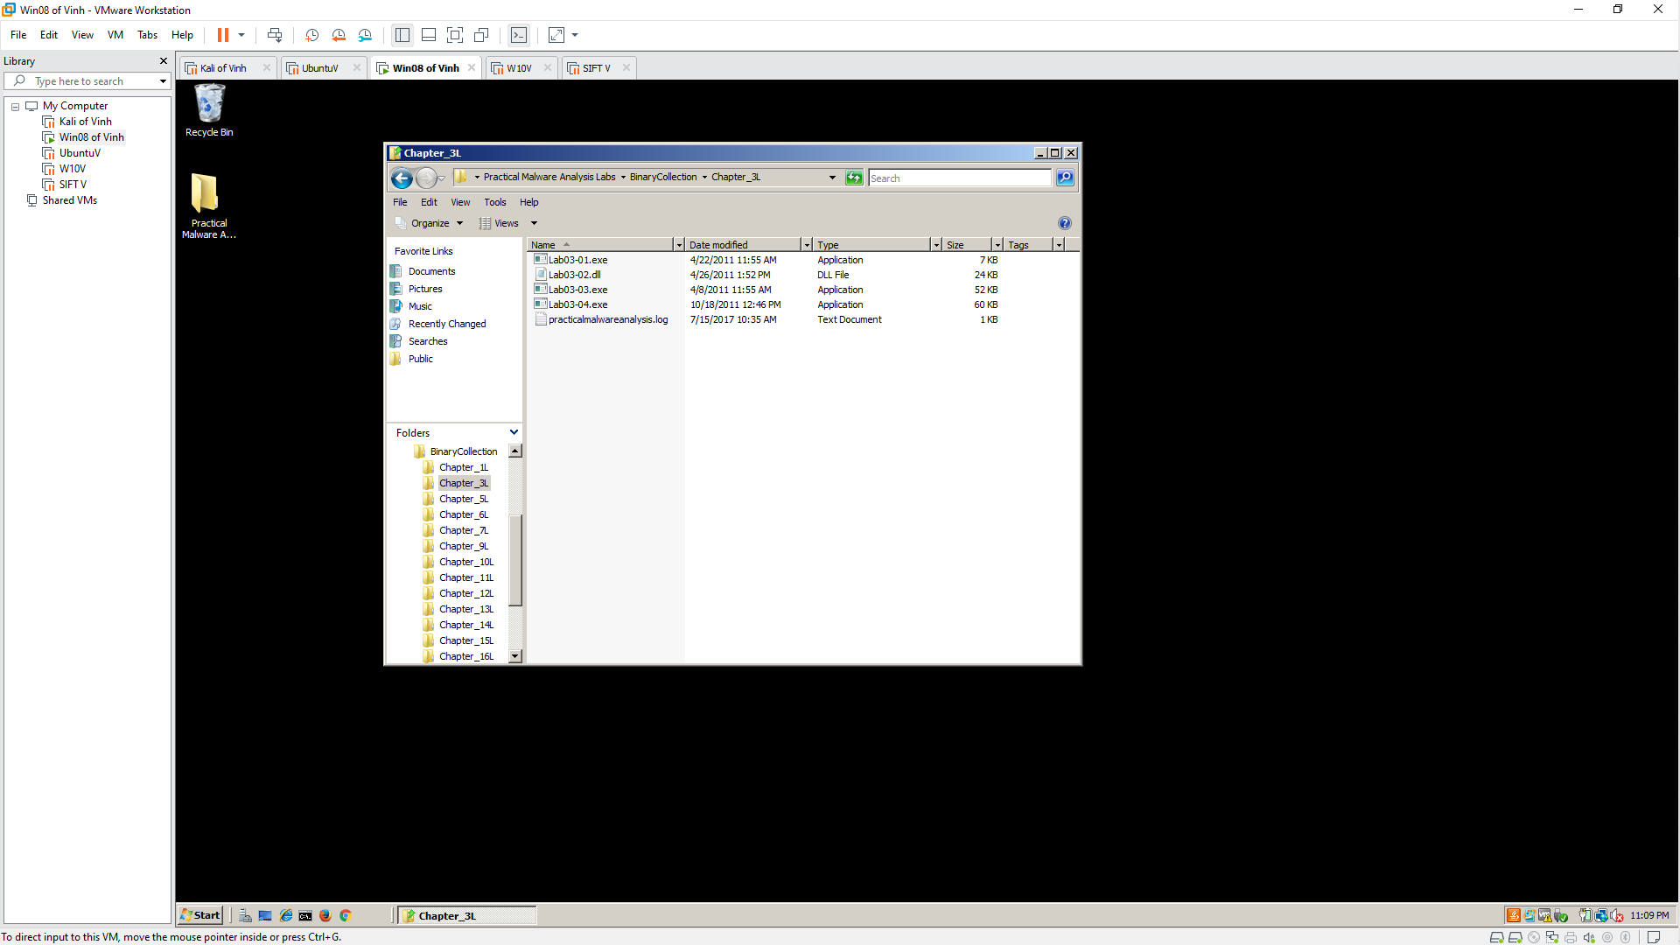

Open Process Explorer and move it so you can see it at the same time as the Explorer window. Scroll to the bottom to show explorer.exe (your desktop) and its children, which are processes launched by the currently logged-in user, as shown below.
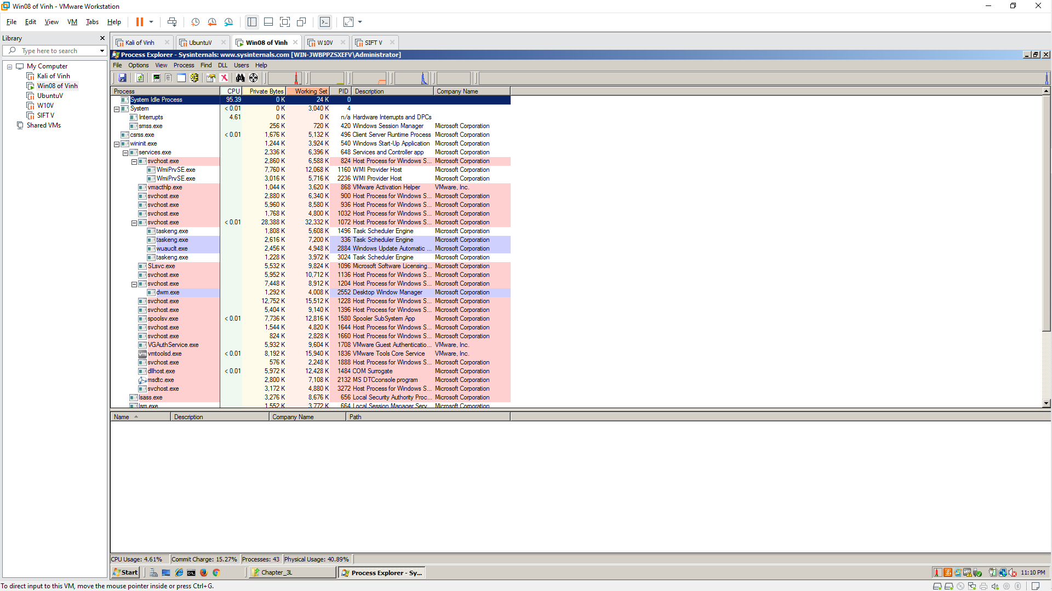

Launch the Malware
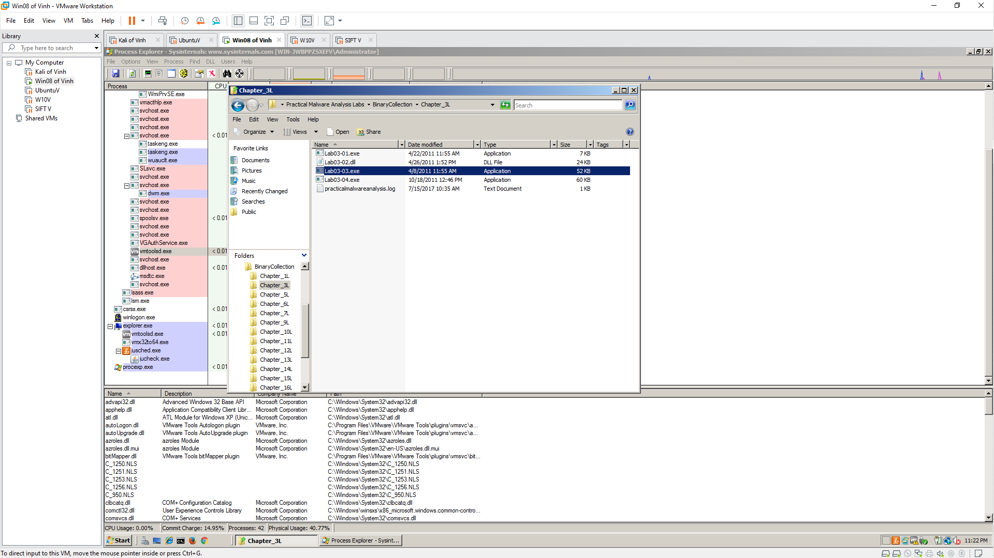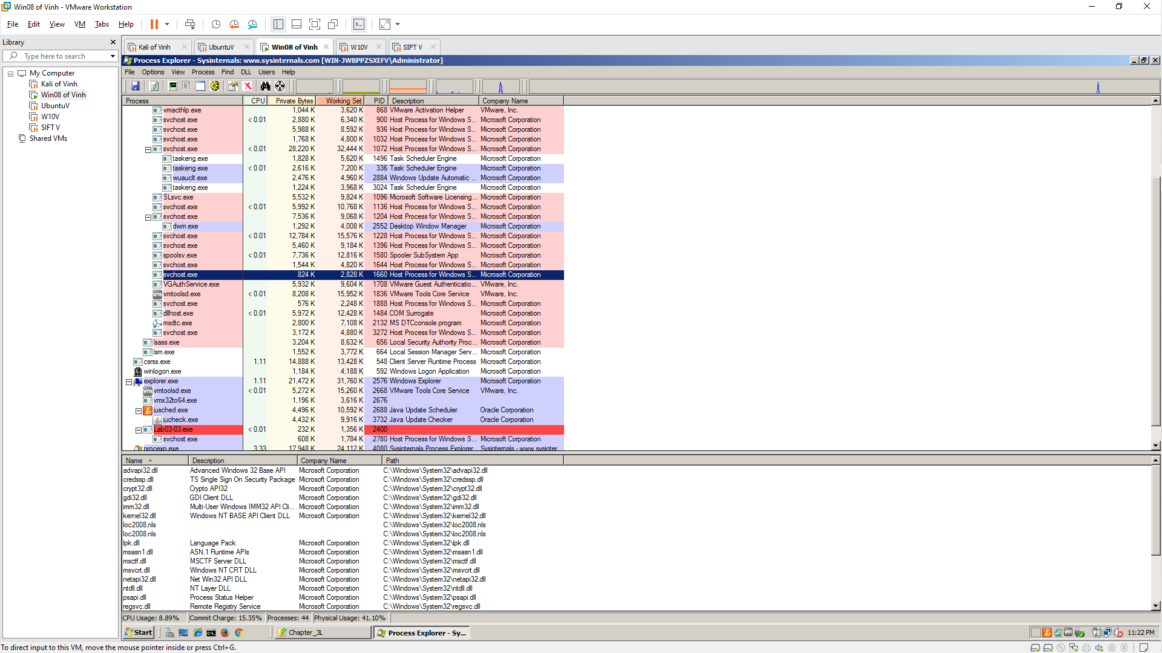
After a second or two, the Lab03-03.exe process terminates, leaving the svchost.exe running as an orphan process, as shown below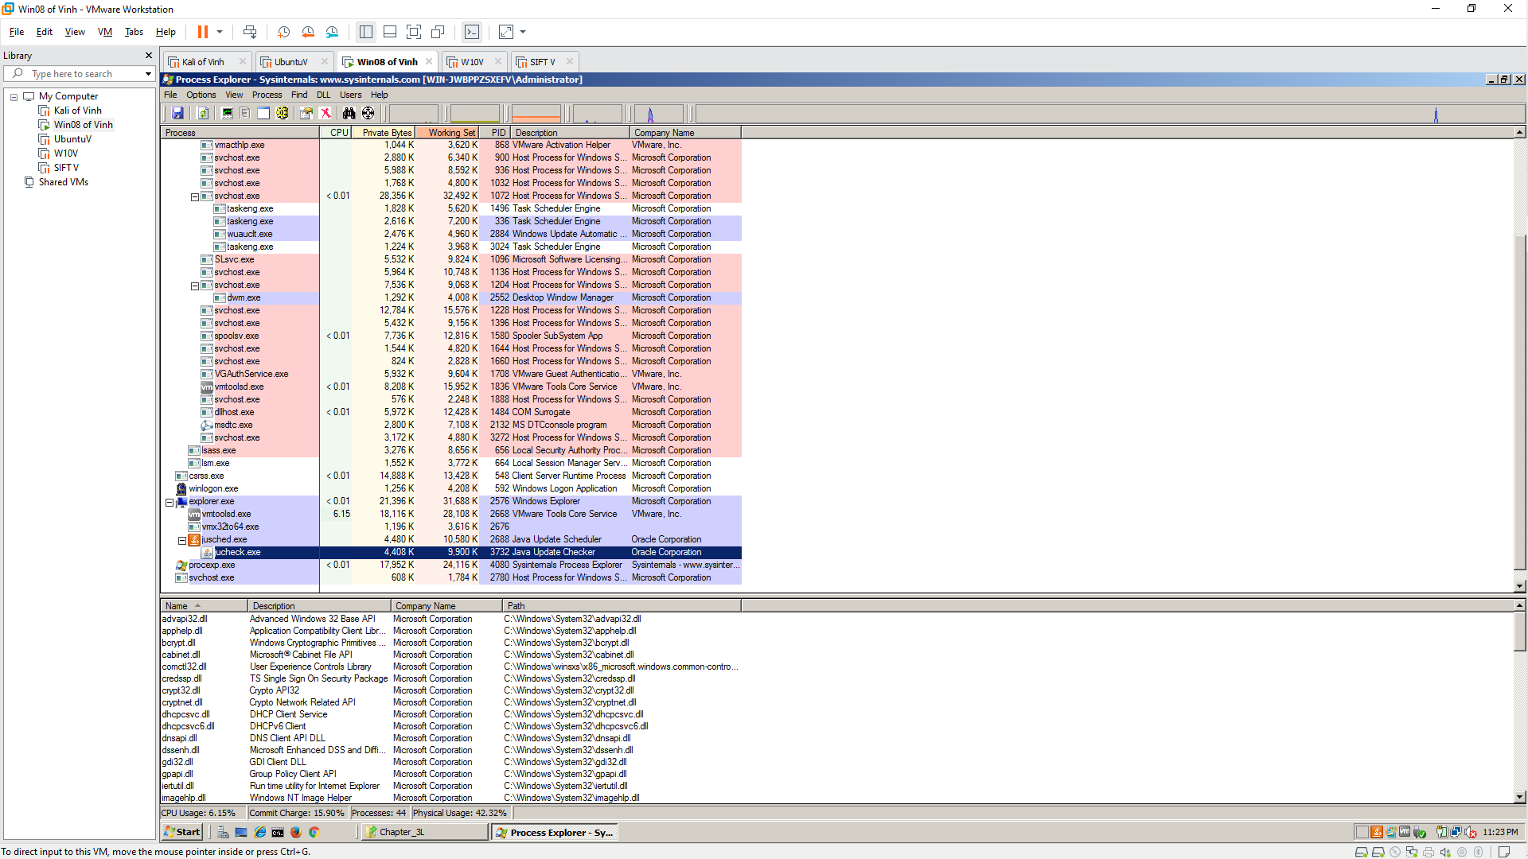

Observing Process Replacement
This svchost process is strange in another way: the code running in RAM does not match the code on the disk.
To see that, in Process Explorer, right-click svchost.exe and click Properties.
Click the Strings tab. At the bottom, make sure Image is selected, as shown below.
These are the strings on the disk, in the real svchost.exe file
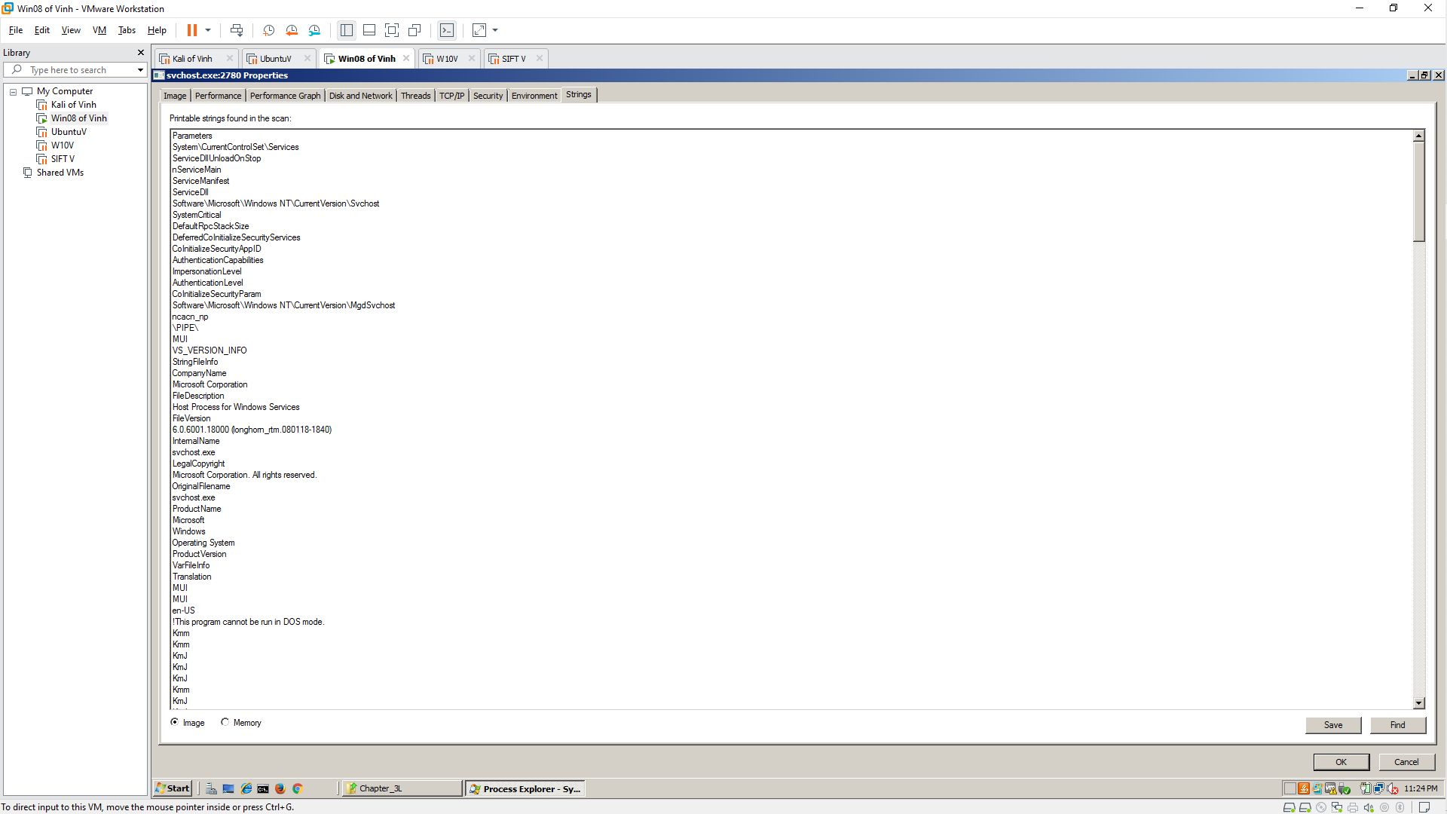

At the bottom of the box, click the Memory button. Now the strings are completely different, and contain these suspicious items: GetActiveWindow and SetWindowsHookExA.
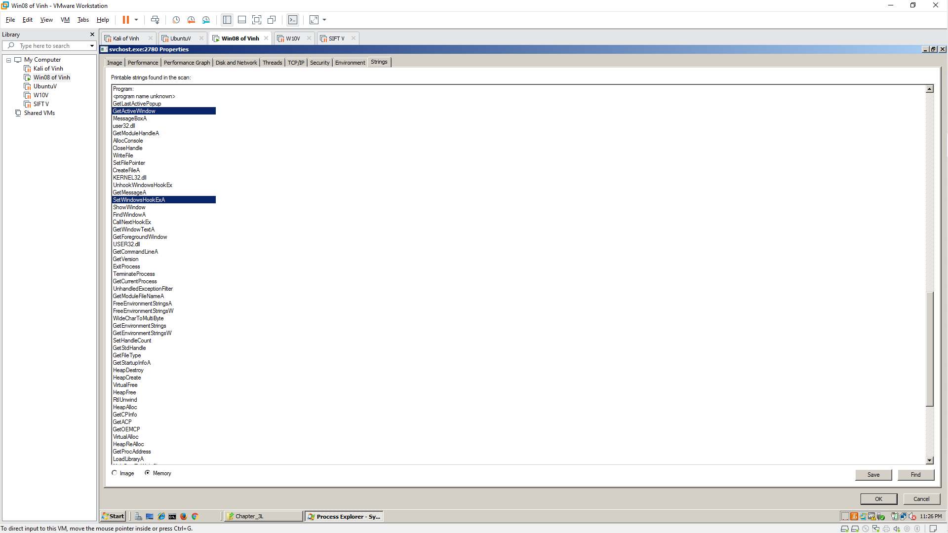
Scroll down and find the string practicalmalwareanalysis.log, as shown below. This may be the filename used to store the keypresses
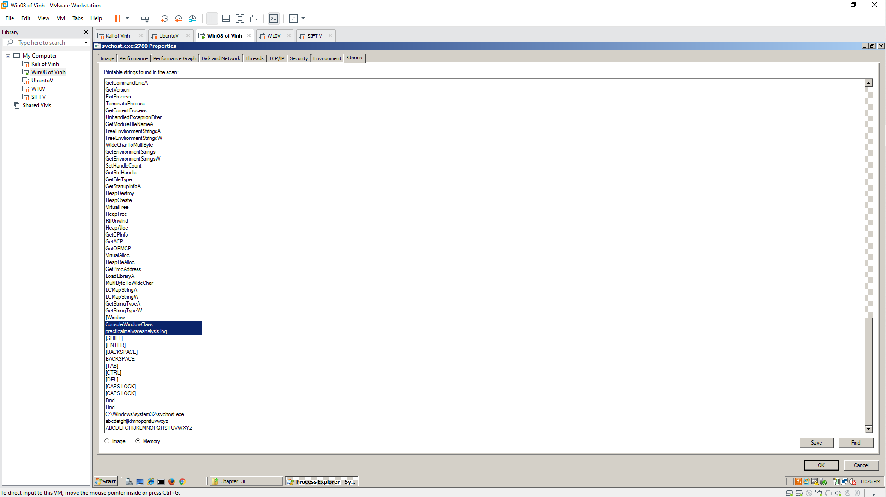

5.1: Recording Your Success
Testing the Keylogger
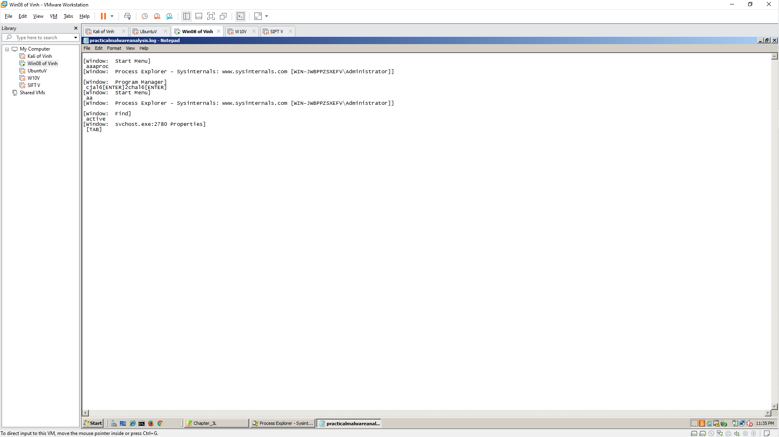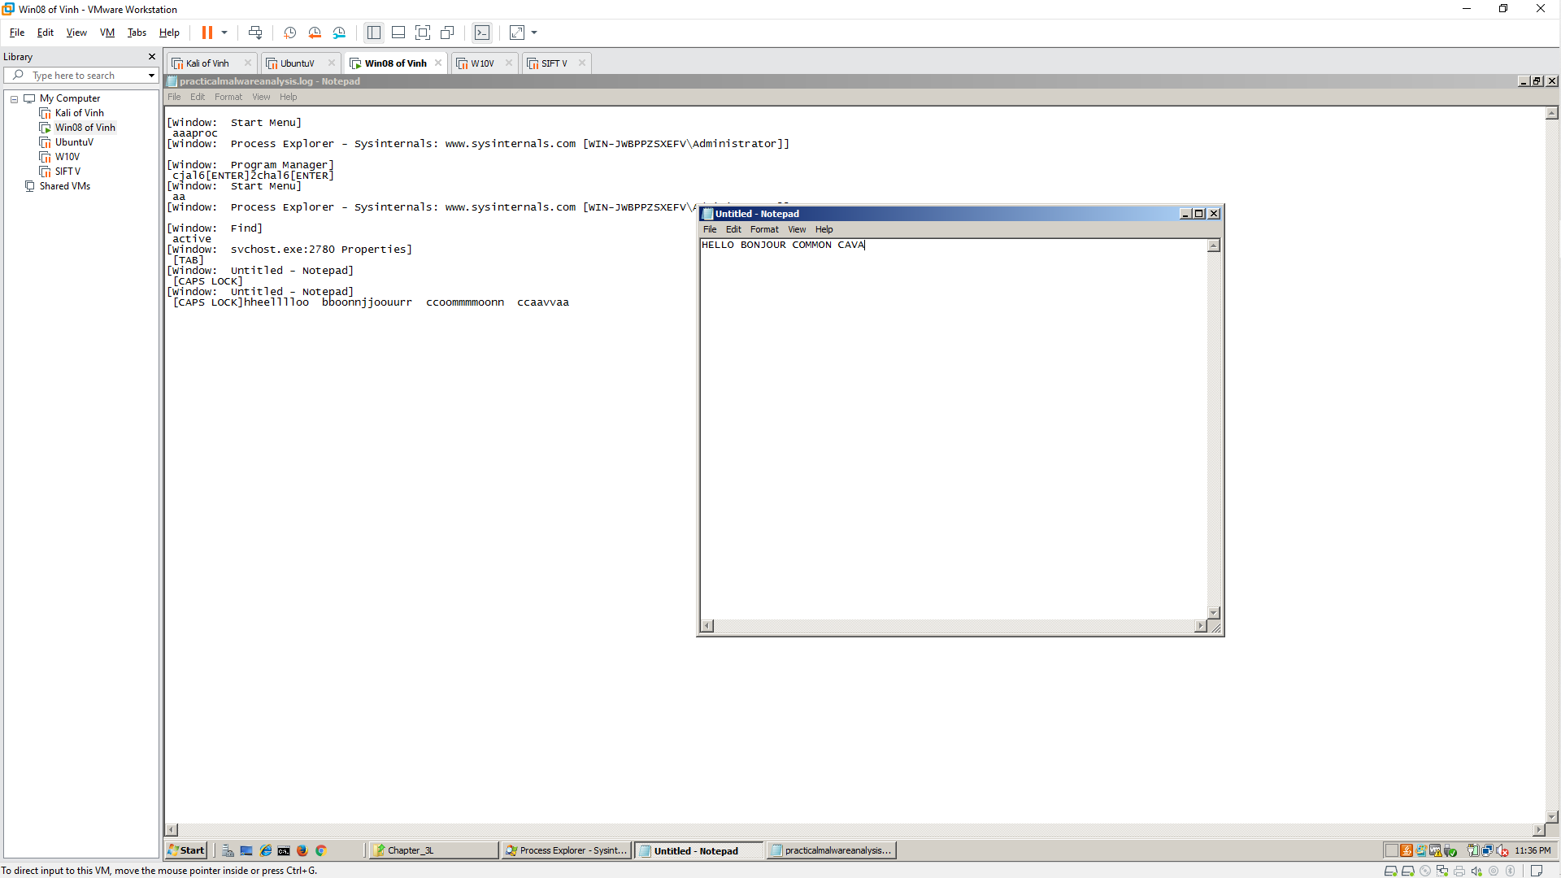
Killing the Keylogger Process
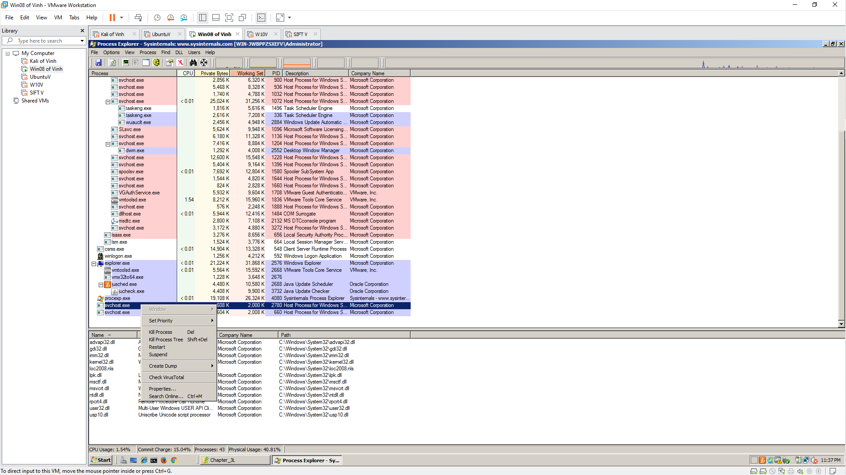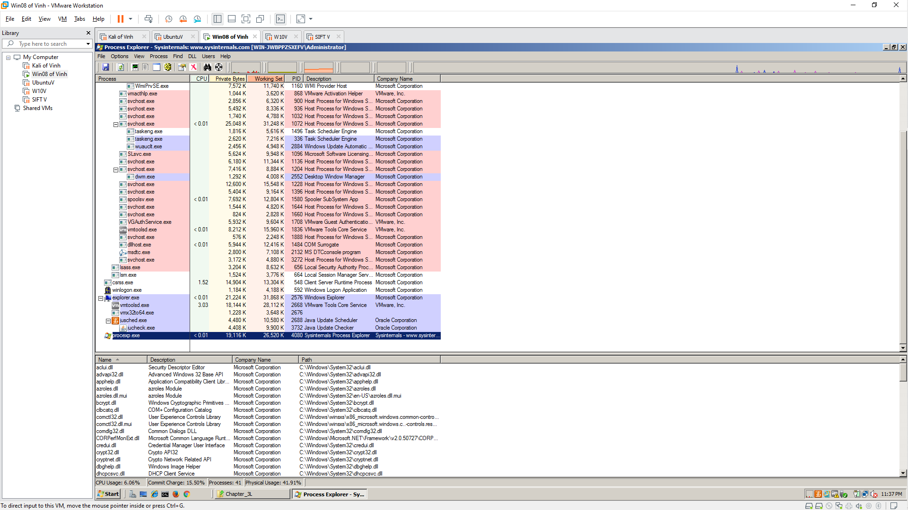
Challenge 5.2: Find the Logfile
In your Documents folder, find the file chal6.exe